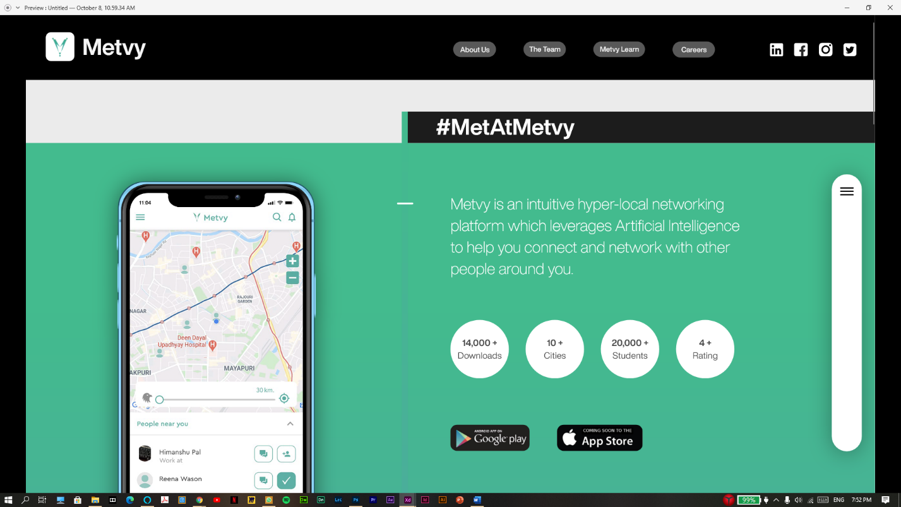

Page - 1

1. Continuous slideshow of three phone screens (Screen – 1.png, Screen – 2.png, Screen – 3.png)
2. Side-bar Expansion and contraction
3. Some elements’ position needs to be fixed while scrolling (Prototype link)
4. Cards reveal themselves as we scroll
5. Add Feedback form under contact us

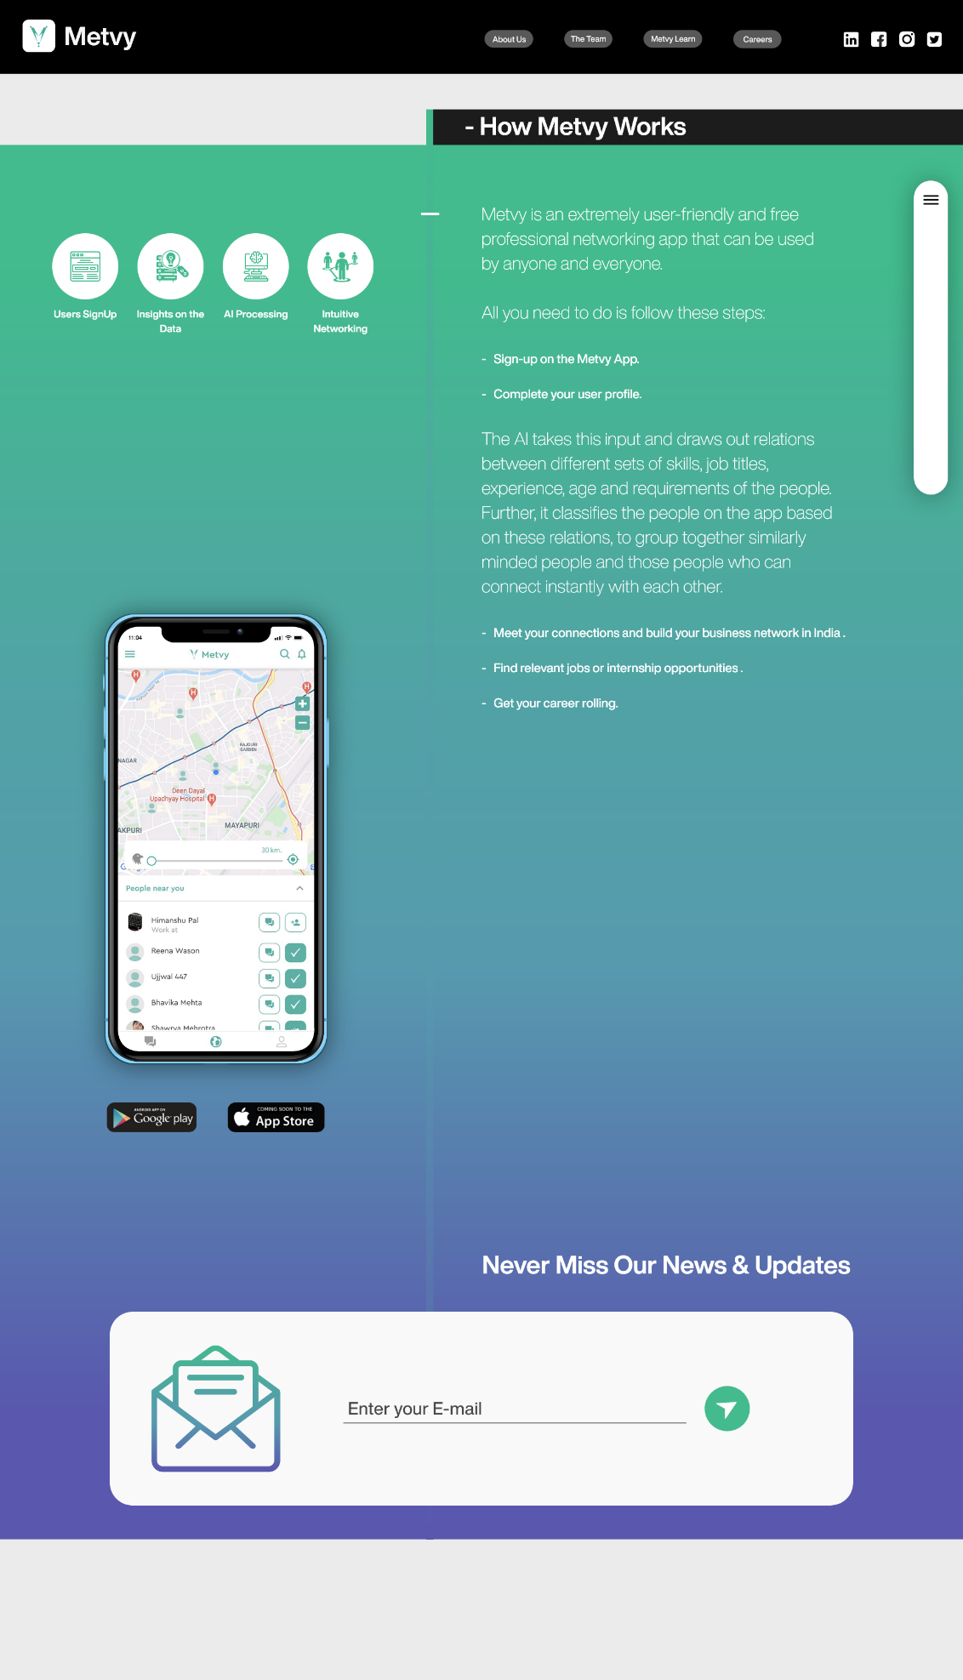

1. On “Page – 1”, click on “How Metvy Works” button and it would lead the viewer to the “Page – 2”.
2. Continuous Screen slideshow to be added (Screen – 1.png, Screen – 2.png, Screen – 3.png)
3. Make the Newsletter registration working
4. Make the Nav bar and the sidebar position fixed when scrolling
5. Sidebar expansion and contraction to be added
6. When page loads, circle one appears, then circle 2, then circle 3, the circle 4 and finally the rest of the content on the page.

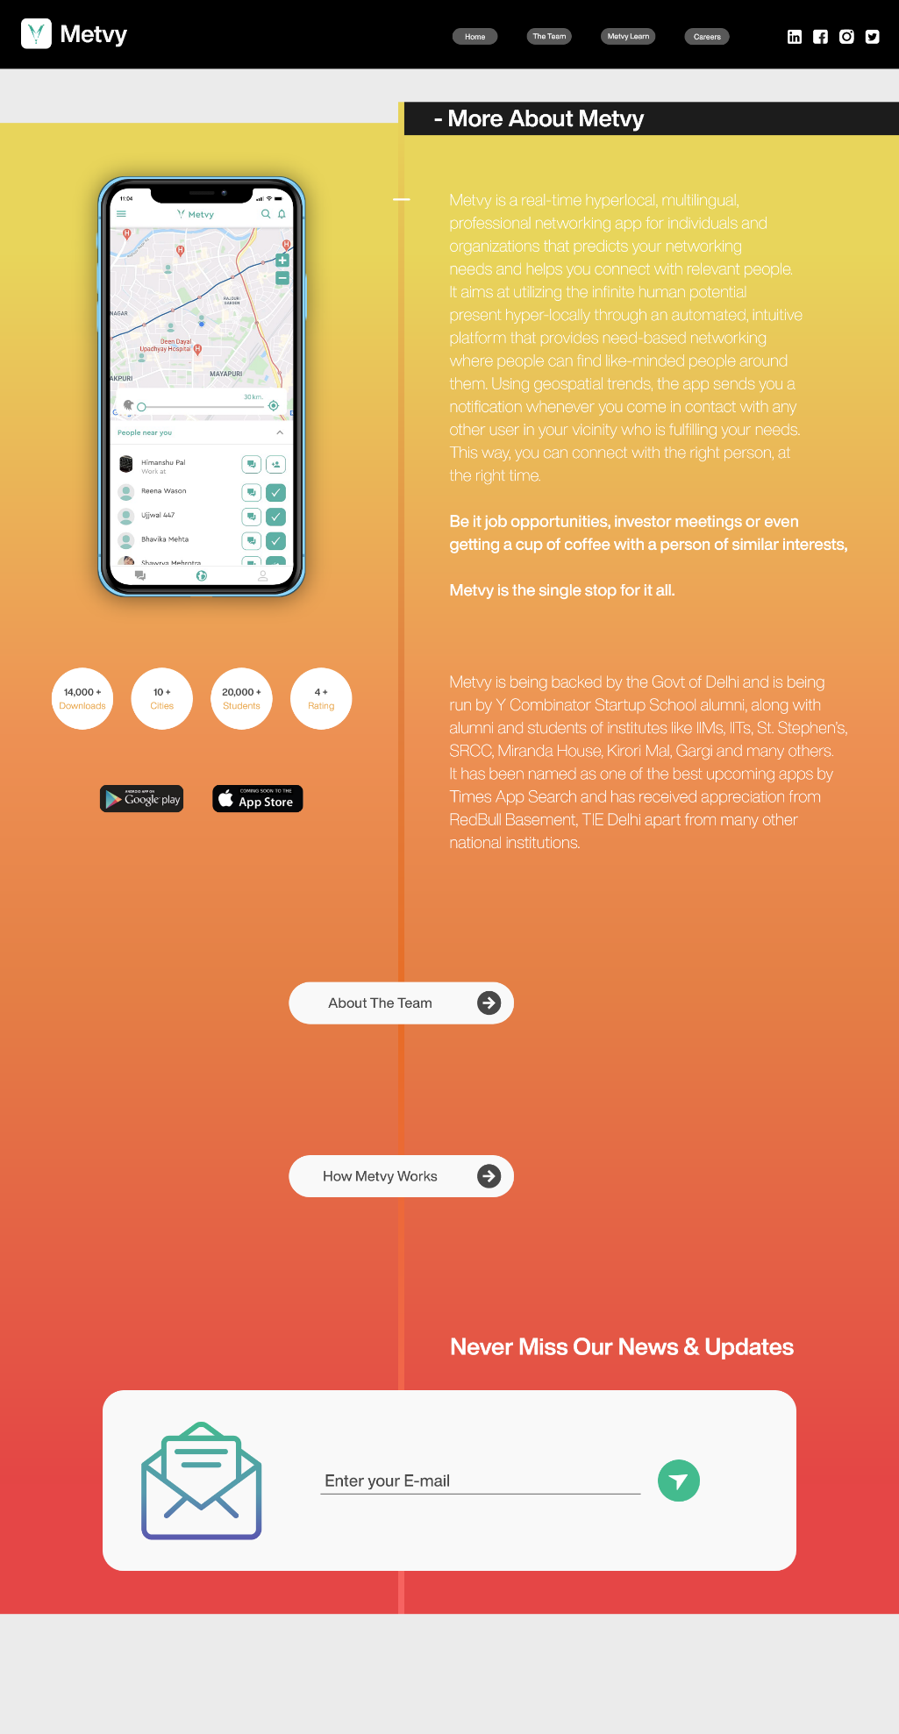

Page – 3 (About Us)

1. Connect “How Metvy Works” button to “Page – 2”
2. Connect “Page – 3(About Us)” to the Home page in the Nav bar
3. Add social Media links
4. Add the animated circle animation here as well
5. Make the Newsletter Subscription box working
6. Add the Continuous screens slideshow (Screen – 1.png, Screen – 2.png, Screen – 3.png)

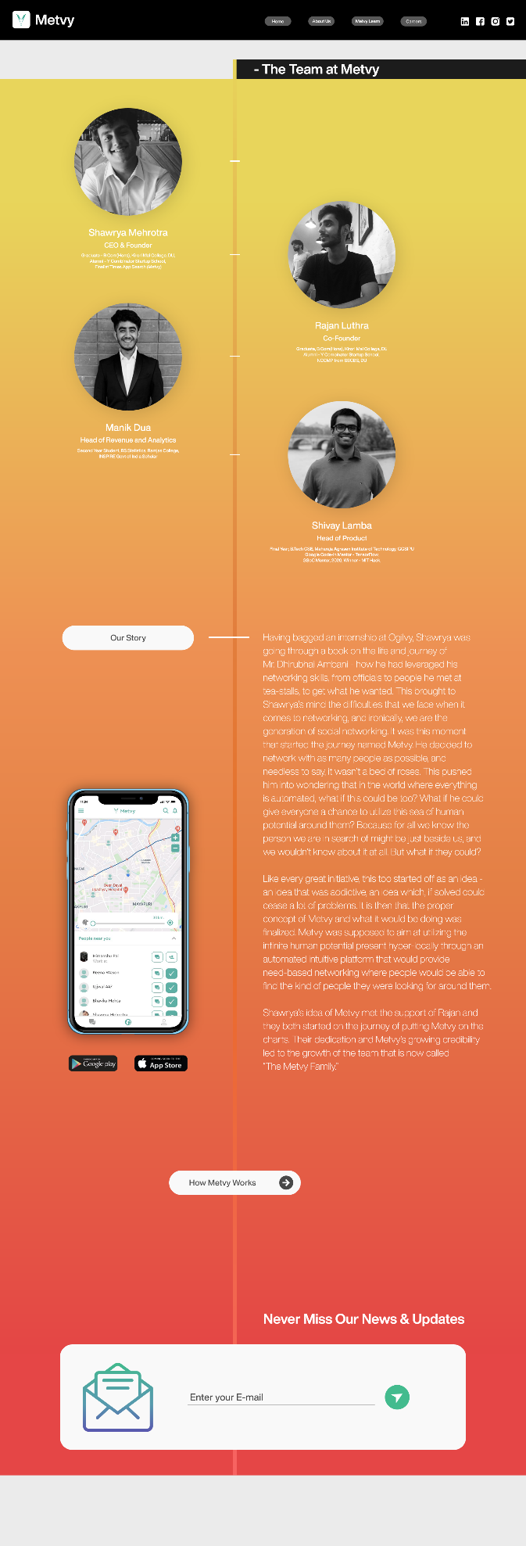  
Page – 4 (The Team)

1. Connect it to other pages
2. Continuous screens slideshow
3. Newsletter registrations
4. Add links to the team’s linkedin profiles
5. Pictures appear as you scroll